PE STUDIES Biomechanics – Revision Notes

Newtons Laws:

* 1st
  + A body will continue in its current state of motion or rest, unless acted upon by an external force
* 2nd
  + Acceleration of a body is directly proportional to the force applied and inversely proportional to its mass
* 3rd
  + For every action there is a equal and opposite reaction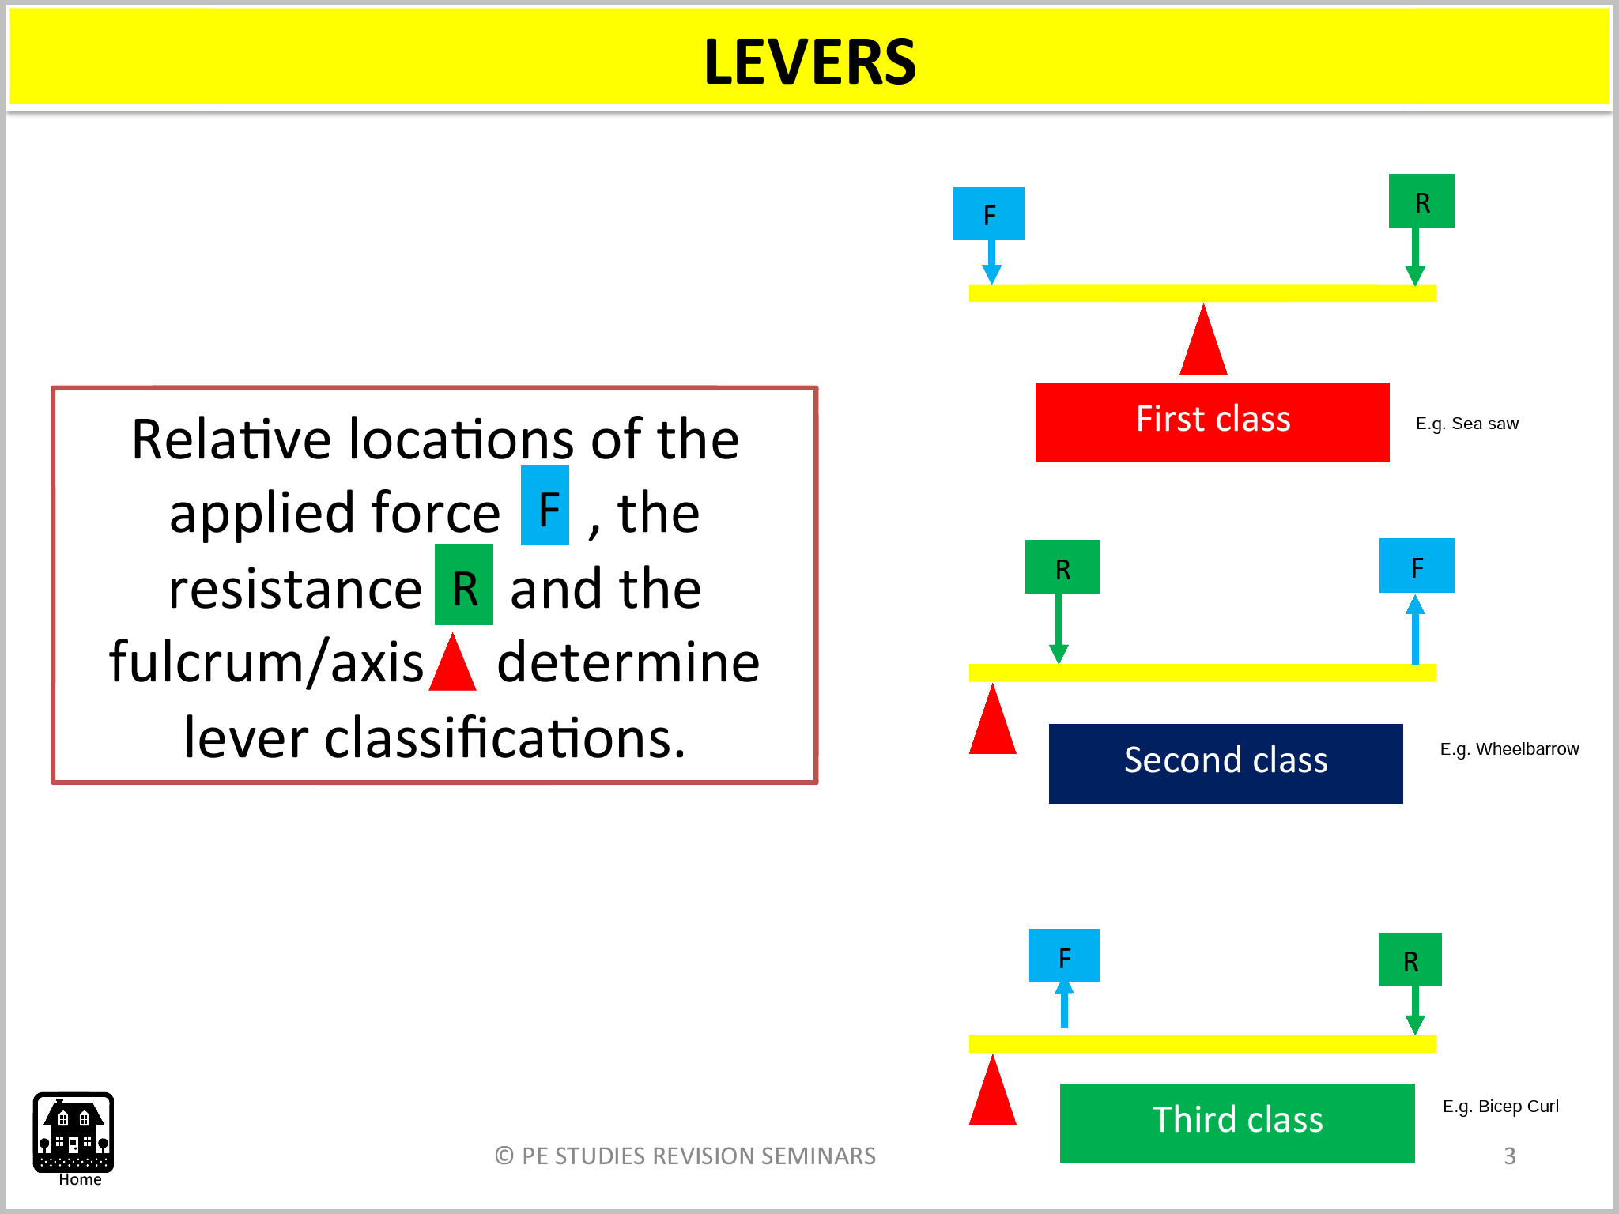

Levers: ***A.R.F:***

* There are three main components to a lever, which we use to classify them, being:
  + Axis or pivot point- ***A***
    - Point about which the lever rotates
  + Weight or resistance which is being moved- ***R***
    - Distance between axis of lever and the centre of the resistance
  + Force applied to move the weight/resistance- ***F***
    - Distance between the axis of lever and the point at which the force is applied
* Levers function to:
  + Increase the application of force to an object
  + Increase the speed of movement
* Classes of Levers
  + First Class
    - Axis/Fulcrum is located in the middle of the lever, with force and resistance on either side
    - E.g. A seesaw, or in the human body flexion of neck, the spine being the axis with mass of head and muscles in neck being the resistance and force respectively
    - The position of the axis in relation to the applied force will determine the mechanical advantage provided by the lever. Axis closer to the force= less force produced, visa versa
  + Second Class
    - The axis is located on an end and force on the other, with the resistive force being located between them
    - E.g. A wheelbarrow, or in the human body a push up, with the centre of mass being resistance, the feet the axis and the arms applying the force
  + Third Class
    - The Axis is located at one end of the lever, with resistance at the other and the force between them
    - A resistance arm ensures an increased speed can be obtained
    - E.g. A bicep curl, where the resistance is provided by the weight being lifted, the axis is the elbow joint and the force applied is from attachment point of the bicep to the forearm
    - Third class levers are effective when using striking implements
    - By increasing the length of the striking arm, it is possible to generate more velocity from the striking surface, therefore increased force applied to the object. However with an increased length there is a decreased control due to the greater weight.
* Factors effecting levers:
  + 1. Length of lever
    - Velocity is greatest strength at the distal end of the lever (not the shorter one)
  + 2. Inertia of lever
    - The longer the lever, generally the heavier it is, and therefore it is more difficult to rotate
  + 3. Amount of force
    - Amount of force an athlete can generate through muscles determines the length of lever that should be used

Momentum:

* Amount of motion possessed by a moving object, measured in Kgm/s
* Transfer of momentum is a process where momentum is transferred from one body part to another
* Momentum of an object directly relates to the mass and velocity of it
* How to increase momentum:
  + Increase velocity or increase mass
  + An object can only have momentum if it is moving
  + The greater the momentum, the larger the force required to stop or slow the object
* Linear Momentum: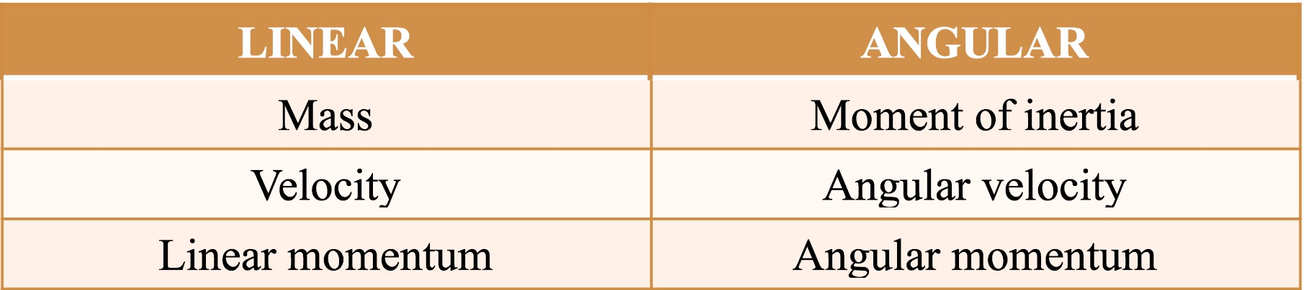
  + The quantity straight line motion possessed by a moving object
  + *Momentum= mass X velocity*
* Angular Momentum:
  + The quantity of angular motion possessed by a rotating body
  + *Angular momentum= moment of inertia X angular velocity*
* Moment of Inertia:
  + A measure of how difficult it is to change an objects current state of rotary motion
  + The tendency of an object to maintain its current state of angular motion
  + Greater moment of inertia= harder it is to change rotation of object
  + *Moment of Inertia = mass X radius of rotation*
  + Mass = mass of object
  + Radius of Rotation = how the mass of the object is distributed about the axis of rotation
* Conservation of Linear Momentum
  + States that the total momentum of two objects in contact must be equal before and after a collision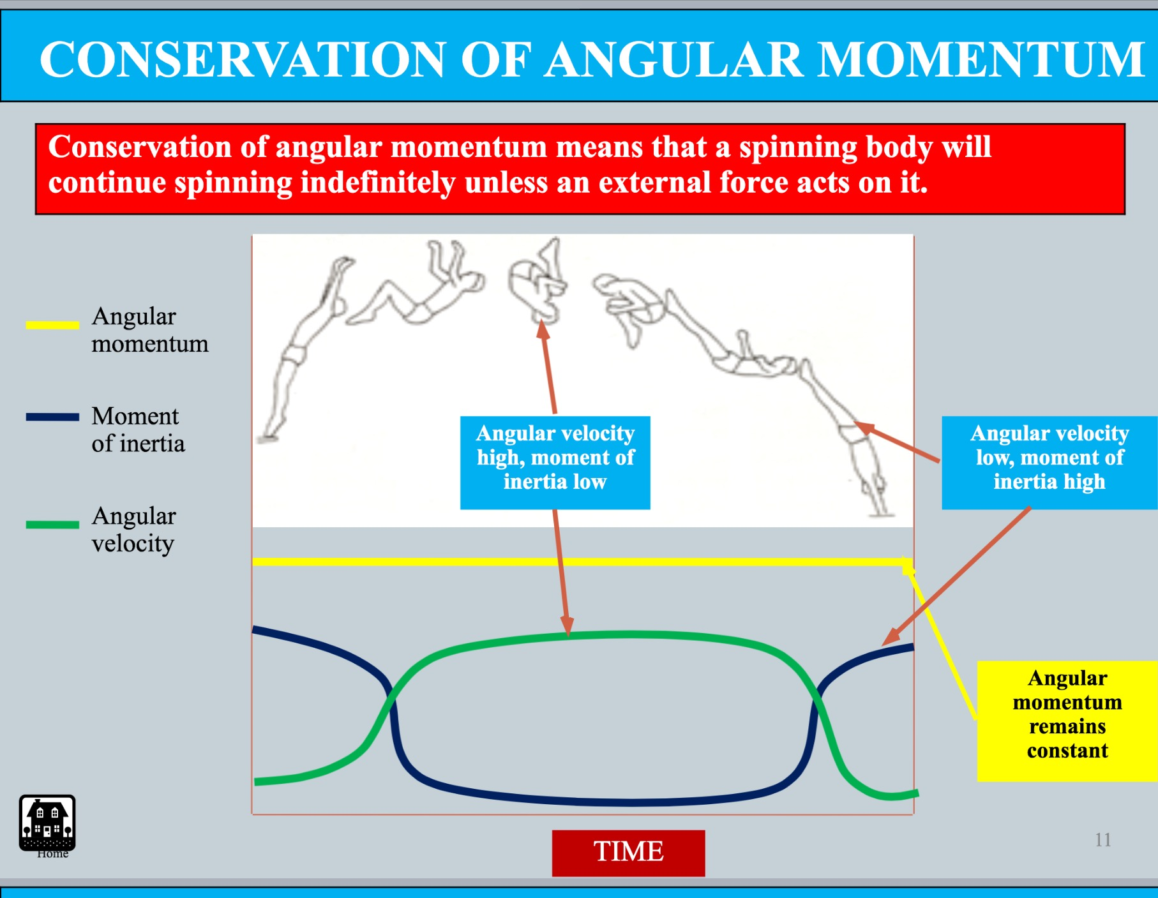
  + In a collision, the momentum of one object is transferred to the other object on contact, resulting in no change in momentum, rather a transfer of momentum
  + In pool, cue balls are an example of a perfectly **elastic collision** and momentum is conserved.
  + In an **inelastic collision (**e.g. tennis forehand**)** some energy is “lost” and momentum is not conserved. This is shown by the sound and change of shape of the objects.
* Conservation of Angular Momentum
* States that a rotating body will continue to turnabout its axis of rotation with constant momentum unless an external force is applied
* Total momentum of a body maintains constant during rotation
* Angular momentum will remain constant unless acted upon by an external force
* To increase angular momentum-
* Increase linear momentum which is then transferred into angular momentum
* Improve segmental interaction at take off

Torque

* Torque refers to the magnitude of turning force
* Eccentric force is the reason for Torque/Angular Rotation
* *T (torque) = F (applied force) X D (distance from axis of rotation)*
* The distance from which the force is applied from the axis/where the torque is produced is called the moment arm
* Types of Force
  + Concentric Force/Translation
    - Force is applied directly through the bodies centre of gravity, producing linear motion
  + Eccentric Force
    - A force applied off centre of an object, producing angular motion
    - When only one eccentric force is applied, both linear and angular rotation occur
    - To increase angular rotation, you can;
    - Increase the amount of force applied
    - Increase the distance from the axis which the force is applied
* Force Couples:
  + When two equal forces are acting in opposite directions on either side of an axis of rotation
  + This causes the forces that produce linear motion to cancel out, causing the object to rotate in a fixed position

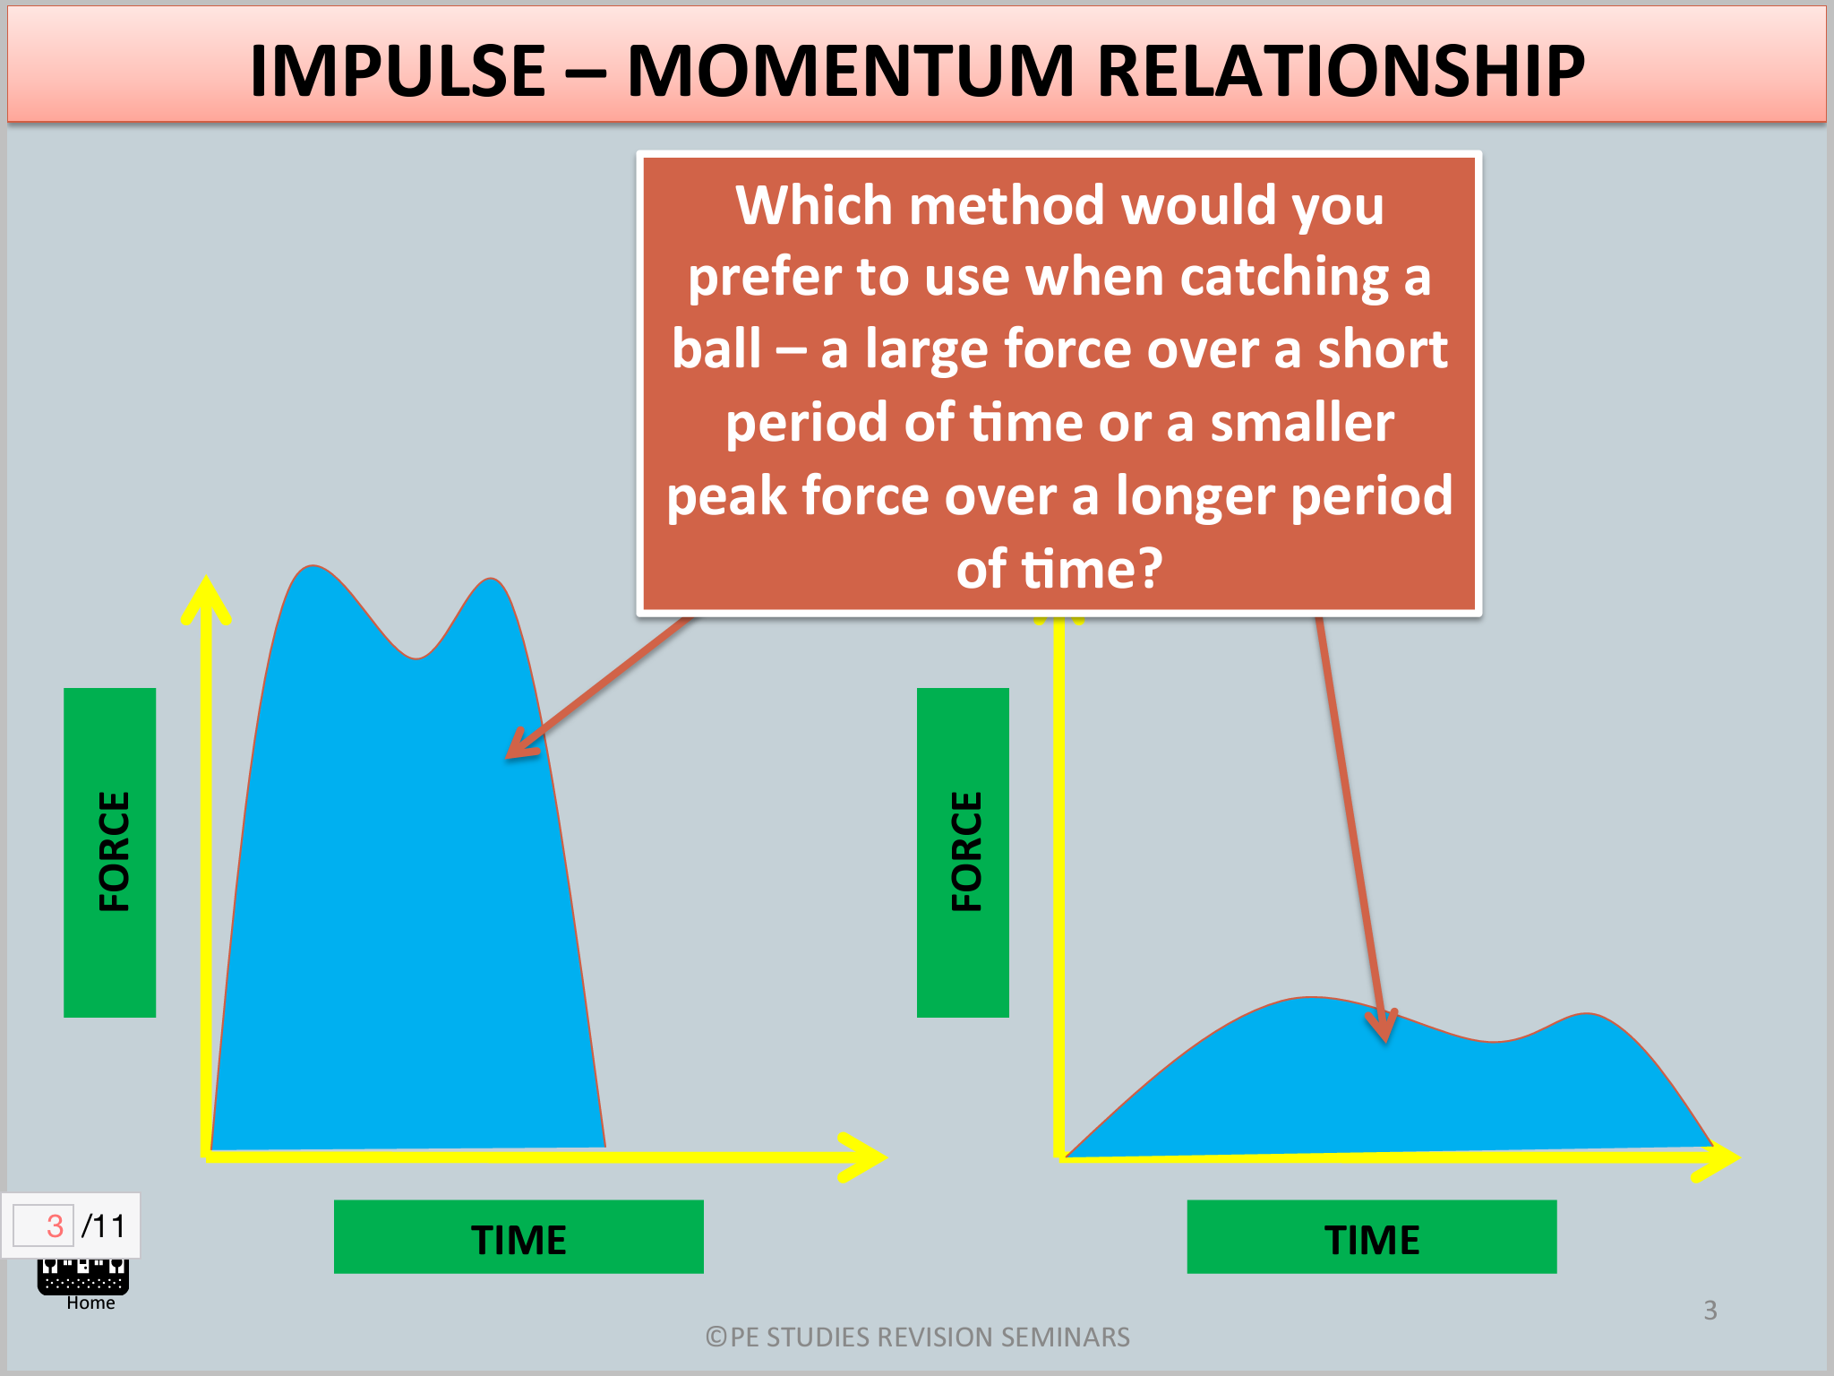Impulse

* The change in momentum of an object
  + *Impulse = Force X Time*
  + *Force = Mass X Acceleration*
  + *Time = the length of time over which the force is applied*
* The longer a force can be applied to an object, and with a greater force of application, the greater the impulse of an object
* Impulse and Sport
  + Impulse is important in impact/collision situations
  + We often want to manipulate the momentum of one of the colliding objects to produce a desired outcome
  + To suit the demands of a situation, we can:
    - Increase Momentum
    - We look to maximise both force and time. But this is difficult to achieve
    - Increase the force applied
    - Increase the time over which the force is applied
    - E.g. Hockey Hit vs. Drag Flick
    - Decrease Momentum
    - In stopping a force we look to increase the time over which the force is applied as to reduce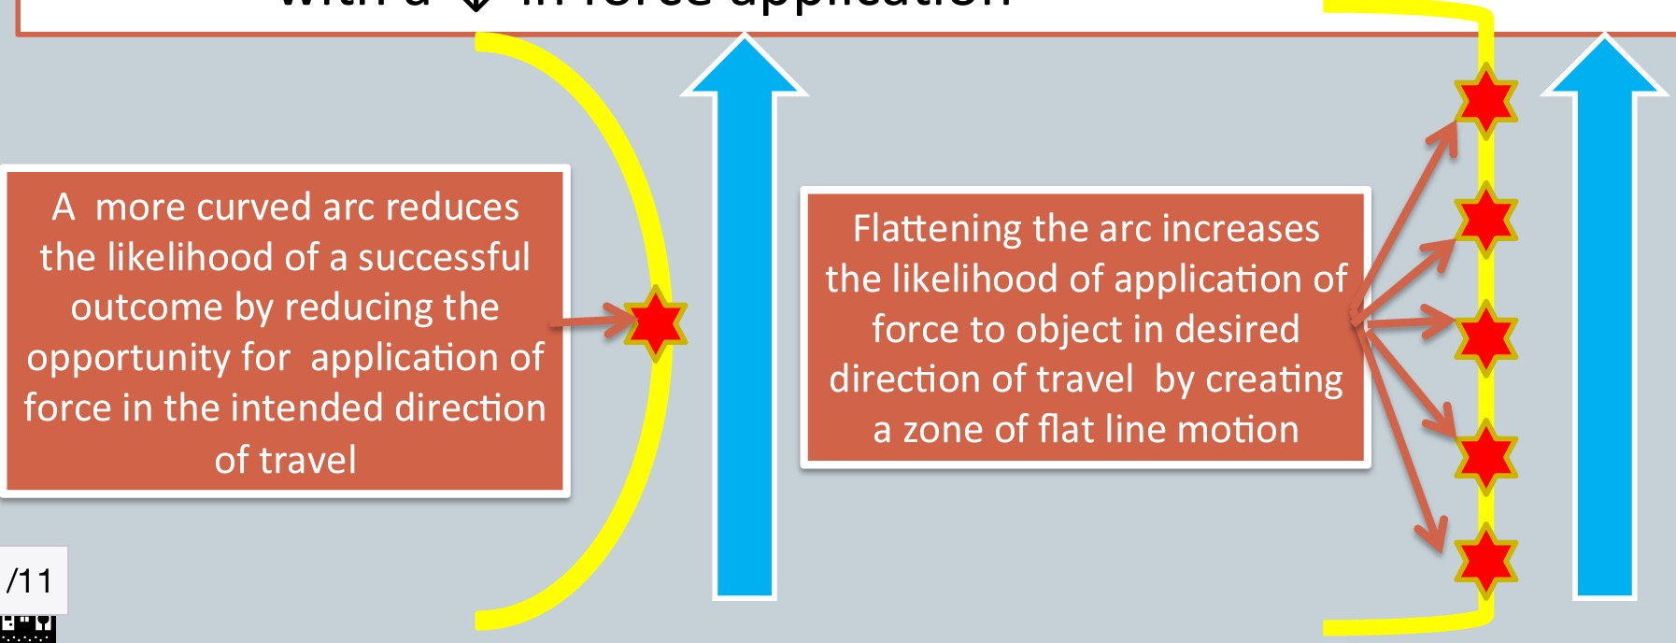 the peak force of the object
    - E.g. When catching a cricket ball, landing in netball
* Flattening the Arc
  + Flattening the swing arc
    - Good technique can increase contact time with an object during collision sports
    - This may produce a greater force application in desired direction
    - May also provide an increased accuracy, however this often comes with a decreased force application
    - Key is to create an area of ‘flat line motion' which allows increased opportunity to make contact with the ball in desired direction of travel

Coefficient of Restitution (COR)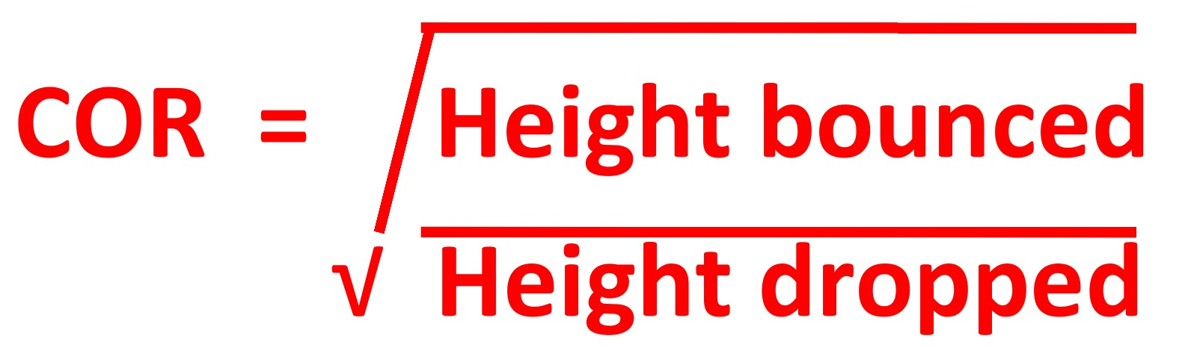

* Measures the elasticity of a collision between an object and a given surface
* Measures the amount of energy left in the object after the collision
* Elasticity
  + A measure of how much rebound exists following a collision
* An objects COR is measured in a scale from 0-1
  + 0: represents a perfectly inelastic collision, effectively stopping on the surface of the collision
  + 1: represents a perfectly elastic collision, so the object returns exactly to where it began
* Factors Affecting COR:
  + Equipment and Materials
    - Condition of the ball - E.g. Calling For a new tennis ball, hence more speed in serve
    - Type of equipment being used - E.g. Wooden bats in baseball to slow down hitters
    - Type and condition of playing surface - E.g. Different surfaces in tennis
  + Temperature of the Balls
    - 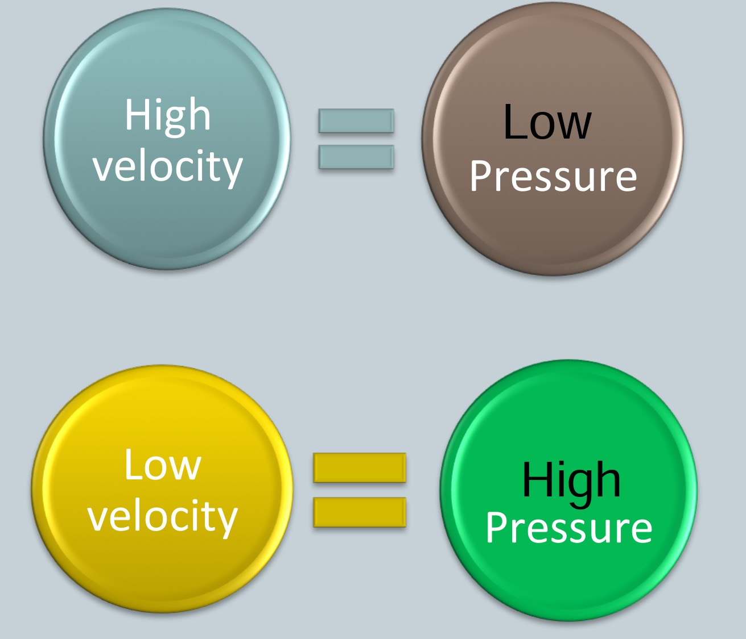Increase in temperature of the ball results in an increase in its COR
    - E.g. Squash ball bounces with greater COR as rally goes on

Spin

* Magnus Effect
  + The effect of rotation on an object’s body as it moves through a fluid
* Bernoulli's Principle
  + States that velocity is inversely proportional to pressure
* Spin in Sport
  + Spin can be implemented into many sporting situations to assist the performer
  + Golf: side spin on the ball allows it to move in the air, back spin makes the ball drop steeper
  + Tennis: top spin adds speed as well as reducing risk of it dipping and hitting the net

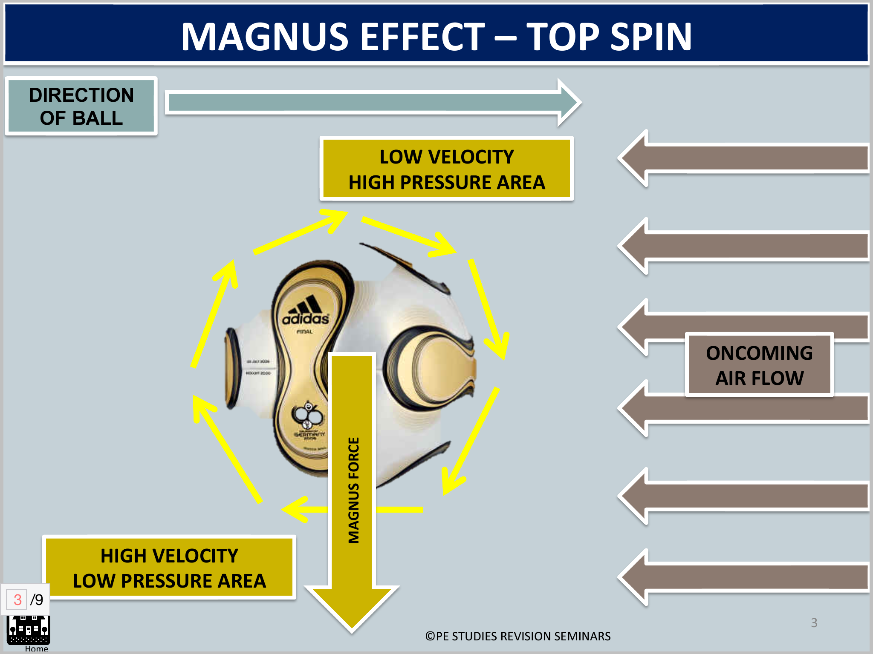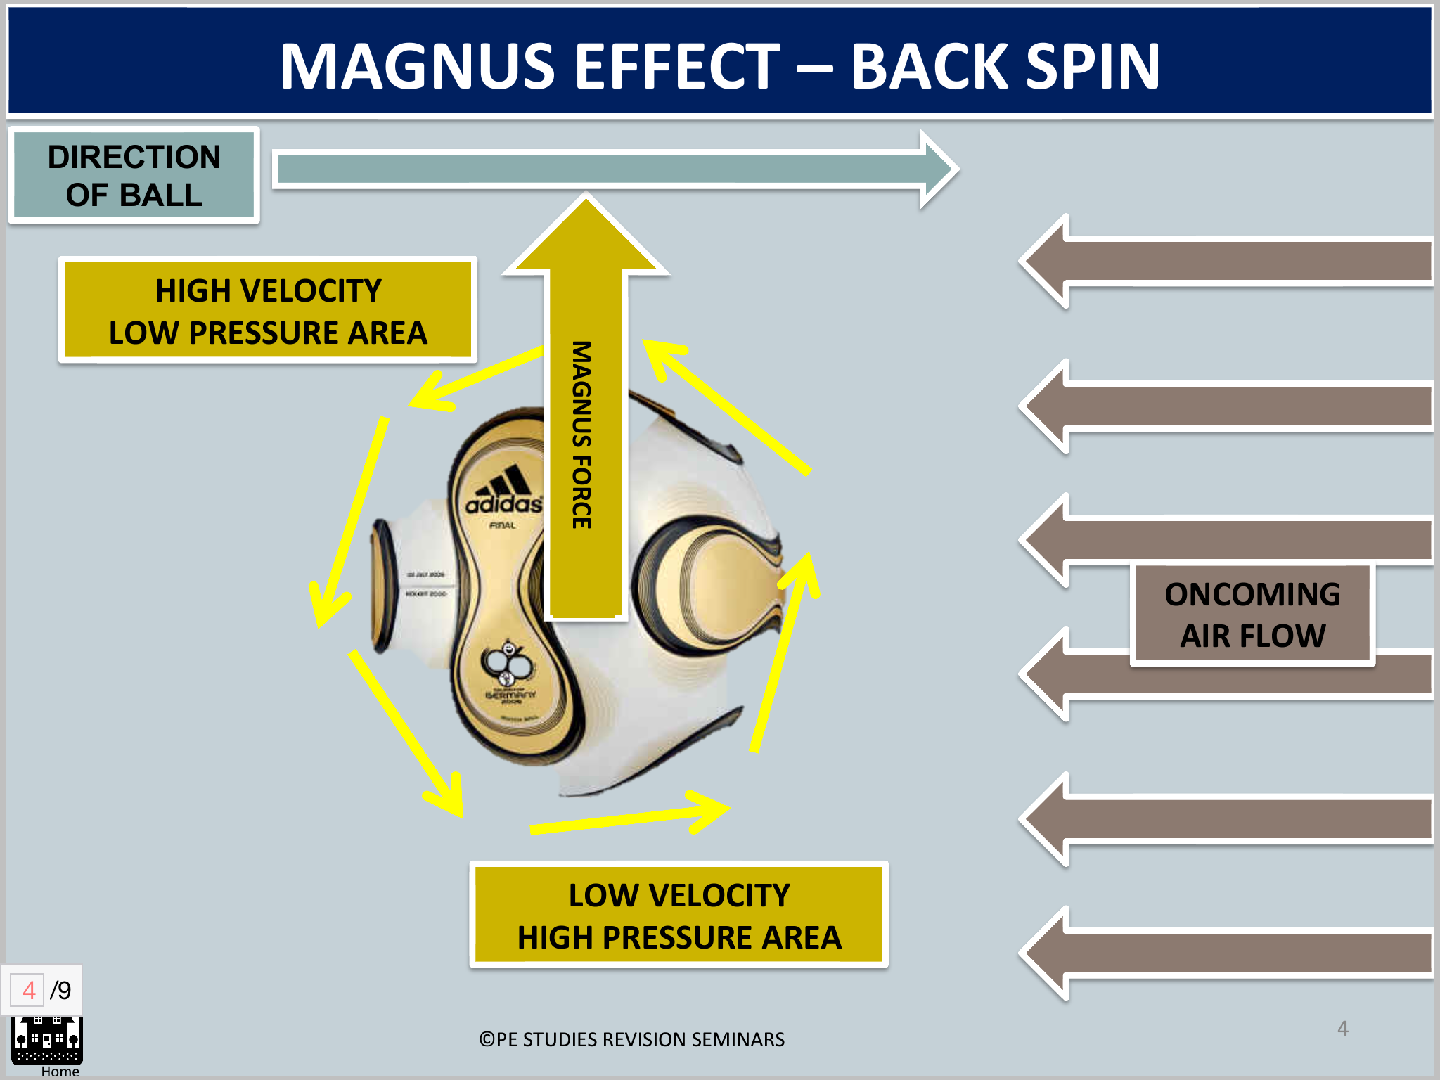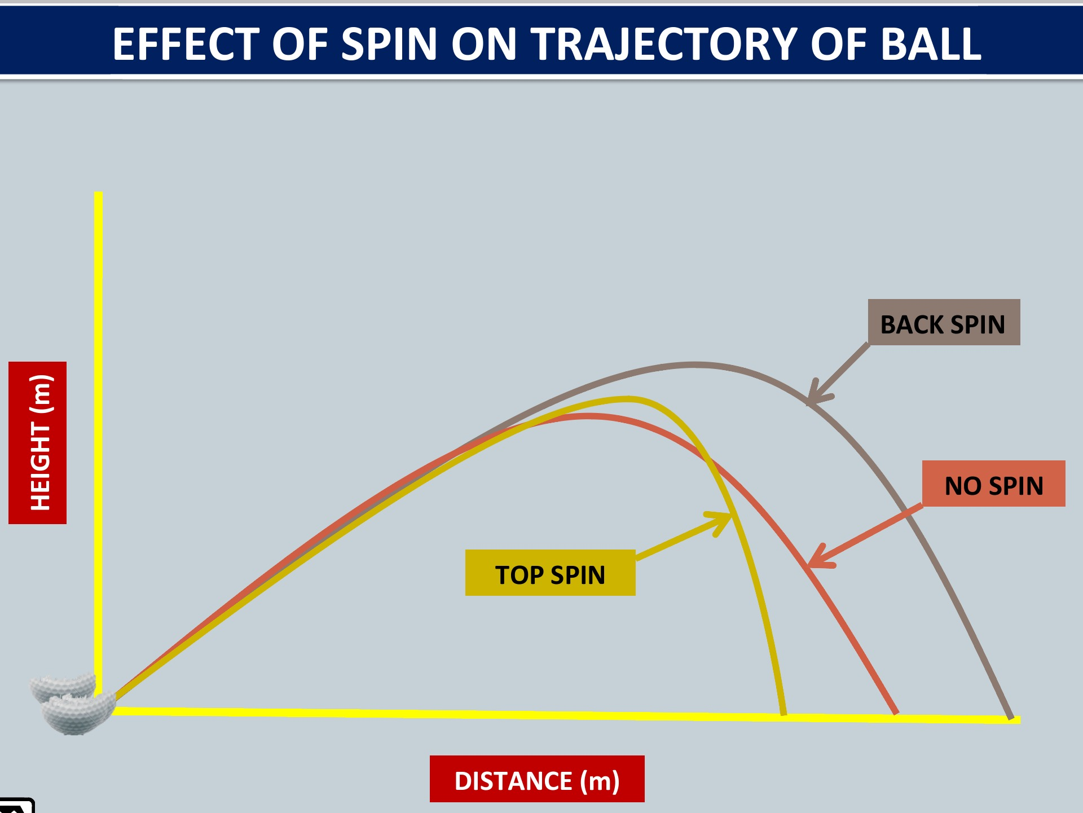

Fluid Mechanics

* Study of forces that develop when an object moves through a fluid medium- Air, Water
* Major fluid forces of interest- Lift, Drag, Buoyancy

Buoyancy

* The upward force that keeps things afloat
* Used to counteract the effects of gravity
* Associated with how well a body floats or how high it sits in the fluid
* Archimedes Principal
  + The buoyant force acting on an object is equal to the weight of the fluid displaced by the object
  + When the forces of the objects mass are equal to or less then those of buoyancy, the object floats
  + When the forces of the objects mass are greater then those of buoyancy, the object sinks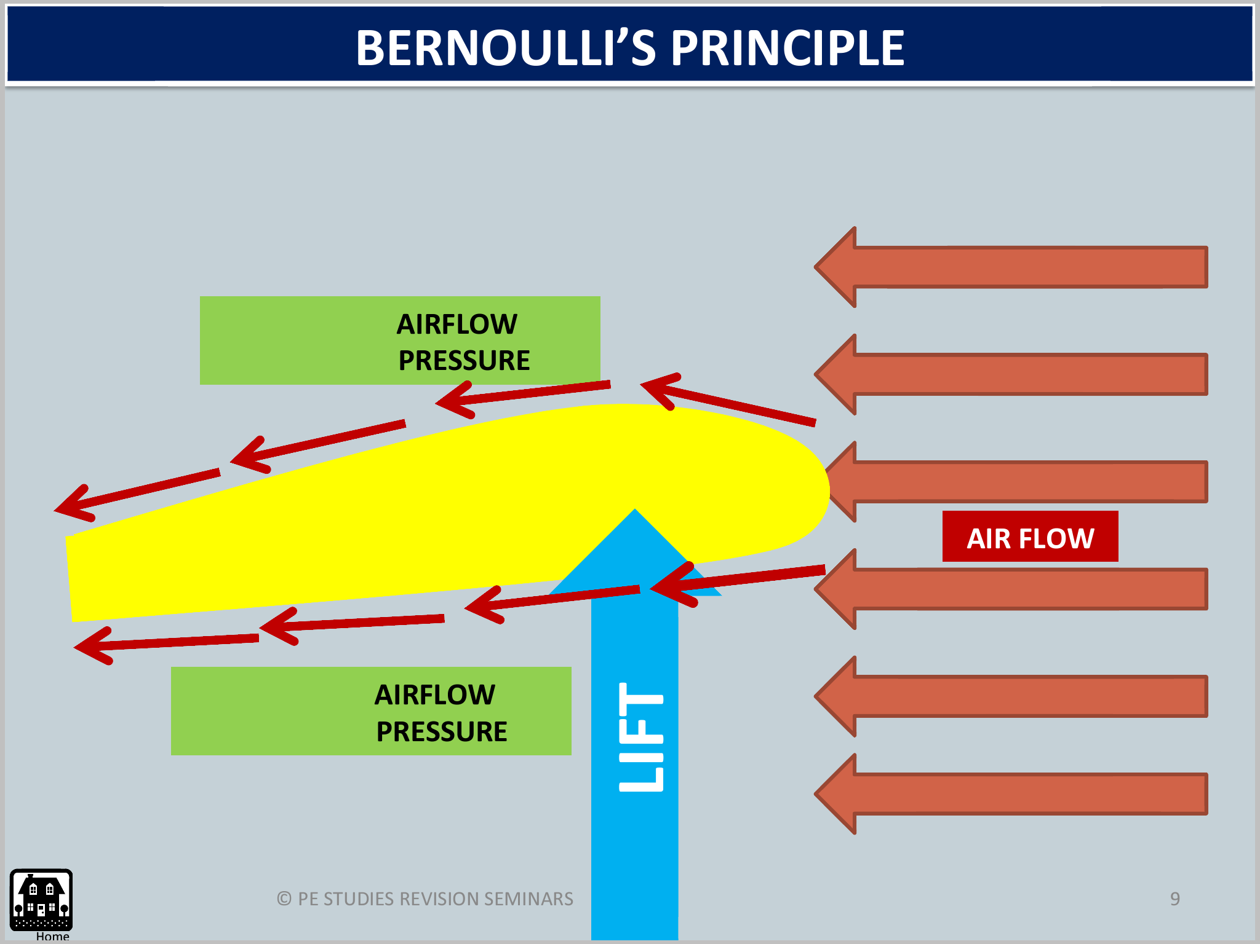
* Describing Buoyancy;
  + Positive Buoyancy- displace a volume of fluid equal to or greater then it's weight, and floats
  + Negative Buoyancy- displaces a volume of fluid less then it's weight, and sinks
  + Neutral Buoyancy- when an object neither sinks or floats but remains suspended in a fluid

Lift

* The component of force that acts perpendicular to the direction of flow
  + Can act either upward or downward at right angles to the direction of flow
  + Only acts on objects which are spinning or not perfectly symmetrical
* Lift is created by different pressures on opposite side of an object due to fluid flow past the object

Drag

* Factors Effecting Drag;
  + Mechanical
  + Drag Co-efficient, Cross Sectional Area, Speed, Surface Roughness, Mass Shape
  + Environmental
  + Air Density, Atmospheric Pressure, Humidity, Temperature
* Fluid resistance
  + As an object moves through a fluid, it disturbs it
  + The greater the disturbance of fluid, the greater the transfer of energy from object to fluid
  + Factors affecting Fluid Resistance;
    - Density:
    - The more dense the fluid, the more disturbance which occurs, and hence more resistance
    - Humid conditions create a greater fluid density
    - Viscosity (thickness of fluid):
    - The more viscous the fluid, the more disturbed the fluid becomes, and hence more resistance
* Types of Drag
  + Surface Drag:
  + Friction produced between fluid and surface of a moving object
  + Factors Affecting;
    - Velocity of moving object
    - Roughness of surface of object
    - Viscosity of the fluid
    - Surface Area of the object
  + Form Drag
  + Resistance created by pressure differential between front and back of moving object through fluid
  + Factors Affecting;
    - Cross Sectional Area of the object presented to the fluid
    - Velocity of object
    - Surface Roughness
    - Shape of the object
  + Wave Drag
  + Resistance formed by creation of waves at the point where air and water interact
  + Factors Affecting;
    - Velocity of wave
    - Technique
    - Open water Vs. Closed
* Boundary Layer
  + Thin layer of air around or attached to the ball
  + Laminar Boundary Layer: smooth flow, large turbulent pocket at back of ball
  + Turbulent Boundary Flow: rough flow, small turbulent pocket at back of ball
  + Boundary Layer Separation
  + Where the boundary layer of air breaks away from the ball
  + The earlier the boundary layer breaks away from the ball, the greater the pressure difference,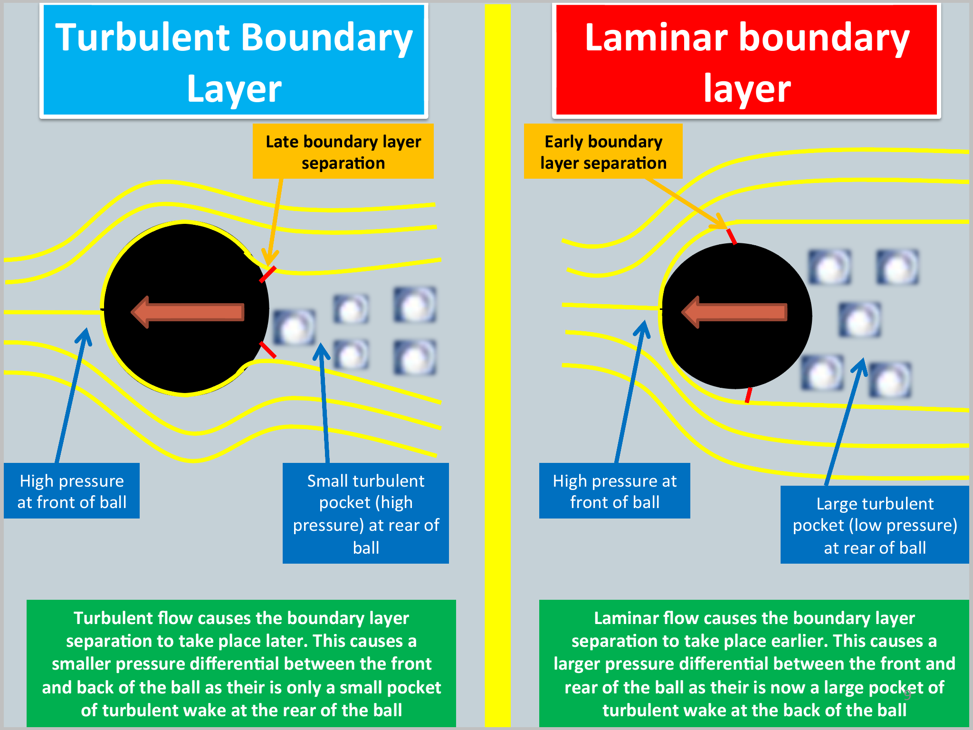 the greater the drag
  + Factors Effecting Boundary Layer Separation
  + Velocity
  + Surface Roughness

Qualitative – uses the senses of the observer i.e. subjective process

Quantitative Analysis – described with numbers e.g. secs or metres

Knudsen and Morrison model of qualitative analysis

1. Preparation
2. Observation
3. Diagnosis/Evaluation
4. Remediation/Intervention
5. Re-observation

Biomechanical Principles of Movement

*Movement Principles- Force-motion, Force- time, Inertia, Range of motion, Balance, Coordination Continuum, Segmental Interaction

*Projectile Principles – Optimal projection, Spin

*Know how to apply these biomechanical principles to analyse physical skills